Week 13 Individual Logbook
Capstone project
Matt Baker
2026
Table of Contents
Hours Breakdown 2
Completed Content/Documentation 3
Team Meetings 3
Advisor Meetings 3
Client Meetings 3
Research 3
Documentation 4
Testing 6
Development 12

Hours Breakdown
Category | Hours completed
Team meetings | 2hrs
Client meetings
Advisor meetings | 3hrs
Research | 1hr 30min
Development | 2hrs 30min
Testing | 1hr 30min
Documentation | 18hrs 45min
Logbook preparation | 1hr
Sick leave/specific conditions
Other
Total Hours for this week | 30hrs 15 min
Running total of hours completed for  Capstone | 339hrs 15min/450hrs

Completed Content/Documentation

Team Meetings
Tuesday, October 6
10:00-11AM (1hr)
Log auditing, assignment of Dave on closeout client presentation, Sam to do research or diagnostics. Fixing discrepancy with Sam’s hours in week 12 group log not being up to date. Team building exercises in the form of quizzes. Left early to do work on self-management review.
5:30 – 6:30 (1hr)
Meeting with Dave and Sam reading over entire self-review document, discussing logging everything that needs doing. Some typos were located, we discussed whether the narratives suggested were accurate. We discussed how the shift in project scope ”philosophy” changes how the Gantt chart is interpreted.
Advisor Meetings
Tuesday, October 6
9:00 - 10:00AM (1hr)
Meeting with Bryce with all present, discussing what panellists are looking for, why Nmap and Wireshark are forensics tools. Setting up packet sniffing, shadow devices, projects for CV, small computers (raspberry pi…). Purchasing second hand technology, (NUC and whatnot). Final video presentation to panel. Applying for jobs, outrageous employer expectations or even undisclosed expectations. Drawing flowcharts, what important steps to include in AI processing. Testing, how did we validate our output. Create graphs that represent the changes in tokens, required processing power, and increase in time it took to generate reports between pre and post 30k context length. Install sysstat for more computation metrics. Include idle baseline. Create a presentation.
Friday, October 9
9:00 – 11:00AM (2hr)
Meeting with Bryce with all present, we gave our progress on the slides Dave is making, the graphs Sam is creating, he taught us how to make master slides. We spoke about recording metrics and displaying them with excel. We talked about job searching, CV, final panel schedule.

Client Meetings

Research
1hr 30 mins (see research log)
Research focussed on content to go into the final report and to validate claims about max GPU temps.

Documentation
Monday, October 5
7:30 – 9:00PM (1hr 30mins)
Working on the primary deliverable project research report. Completed a Wireshark dataset findings section and discussion as well as a table of all test cases, source file types, and converted file types.
Tuesday, October 6
12:00 – 4:00 (4 hrs)
Work on self-management review. First settling the word document as a shared OneDrive document so that changes are attributable and people don’t have to use web browser version of word to modify the document. Added cover page. Added all evidence to appendices list and cross referenced them to the related content in the discussion sections. Added all individual logbook evidence and discussion into the document, formatting appropriately. Created and added headings for all weekly logbook evidence so that they wouldn’t link to the table of contents and bloat it. Also set all “Experience, reflection, action headings to one for the same reason.

5:00 – 5:30 (30mins)
Continuing previously logged work after my penetration testing lecture. Particularly formatting the rest of ERA headings to heading 4 and adding Olivia’s discussion and logbook evidence content and cross referencing it.
Wednesday, October 7
10:15 – 12:45 (2hrs 30 min)
Final touches, editing, structuring, adding lacking content to many sections the self-management review. Changed font everywhere other than the appendices to times new roman 12pt justified with 1.15 line spacing. Removing some concatenations. A document exists where my specific in text changes are commented on by me to validate they were done by me. Shifted around sections with headings and appendices so they all start on their own page.

Friday, October 9
12:45 – 4:00 (3hrs 15min)
Running LLM scripts 3 times per test case file to collect metrics for generating charts.
Using a simple script to capture live GPU data with smi and appending it to a file, stopping the capture once the script has finished.
Example of a capture
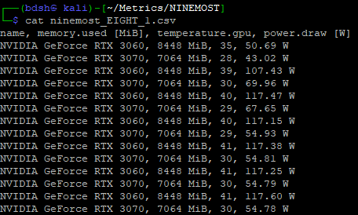
This data will be used by Sam to average out the GPU statistics. But during this time I recorded all other statistics and ran the script for every test case for every tool 3 times.
Example of working through files to create performance captures
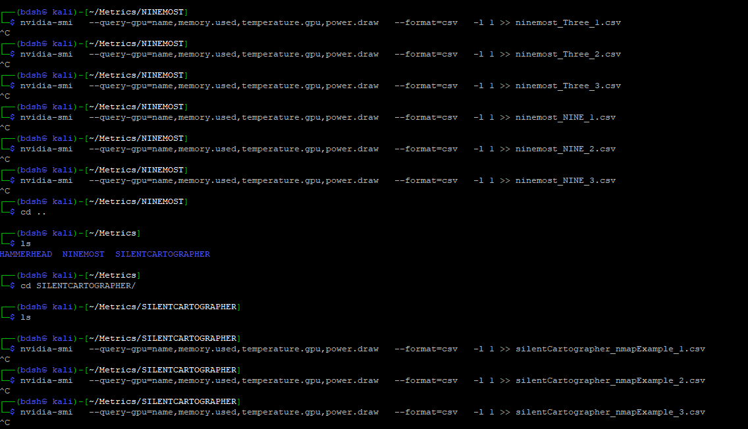
Foremost Scripts Data
This table records metrics gathered during AI report generation for Foremost data (disk images).
GPU 1 = 3060, GPU 2 = 3070
Input Data | Test | Time (s) | Input Tokens | Output Tokens | Total Tokens | GPU 1 VRAM (MiB) | GPU 2 VRAM (MiB) | GPU 1 Power (W) | GPU 2 Power (W)
EIGHT.dd | 1 | 38.86 | 2020 | 750 | 2770
EIGHT.dd | 2 | 13.65 | 2020 | 771 | 2791
EIGHT.dd | 3 | 13.22 | 2020 | 749 | 2769
Three.dd | 1 | 35.58 | 911 | 787 | 1698
Three.dd | 2 | 11.63 | 911 | 655 | 1566
Three.dd | 3 | 20.88 | 911 | 1250 | 2161
NINE.dd | 1 | 35.04 | 2020 | 694 | 2714
NINE.dd | 2 | 13.80 | 2020 | 769 | 2789
NINE.dd | 3 | 14.35 | 2020 | 811 | 2831

Nmap Scripts Data
This table records metrics gathered during AI report generation for Nmap data (Nmap scans).
GPU 1 = 3060, GPU 2 = 3070
Input Data | Test | Time (s) | Input Tokens | Output Tokens | Total Tokens | GPU 1 VRAM (MiB) | GPU 2 VRAM (MiB) | GPU 1 Power (W) | GPU 2 Power (W)
Nmap_example.xml | 1 | 98.29 | 21565 | 2490 | 24055
Nmap_example.xml | 2 | 53.69 | 21791 | 2947 | 24735
Nmap_example.xml | 3 | 47.89 | 21791 | 2742 | 24533
SOITnetworkscan.xml | 1 | 64.12 | 17368 | 2229 | 19587
SOITnetworkscan.xml | 2 | 39.90 | 17470 | 2164 | 19634
SOITnetworkscan.xml | 3 | 41.75 | 17470 | 2369 | 19839
28sepServiceScan.xml | 1 | 84.18 | 32135 | 2246 | 34381
28sepServiceScan.xml | 2 | 41.37 | 32156 | 2225 | 34381
28sepServiceScan.xml | 3 | 39.64 | 32156 | 2235 | 34391

Wireshark Scripts Data
This table records metrics gathered during AI report generation for Wireshark data (Packet captures).
GPU 1 = 3060, GPU 2 = 3070
Input Data | Test | Time (s) | Input Tokens | Output Tokens | Total Tokens | GPU 1 VRAM (MiB) | GPU 2 VRAM (MiB) | GPU 1 Power (W) | GPU 2 Power (W)
evidence01.pcap | 1 | 149.46 | 55167 | 2460 | 57627
evidence01.pcap | 2 | 51.36 | 55241 | 2721 | 57962
evidence01.pcap | 3 | 49.73 | 55241 | 2771 | 58012
evidence02.pcapng | 1 | 92.05 | 33714 | 2527 | 36241
evidence02.pcapng | 2 | 46.79 | 33635 | 2512 | 36147
evidence02.pcapng | 3 | 44.00 | 33635 | 2457 | 36092
evidence03.pcap | 1 | 90.02 | 33612 | 2378 | 35990
evidence03.pcap | 2 | 45.70 | 33725 | 2480 | 36205
evidence03.pcap | 3 | 45.48 | 33725 | 2570 | 36295

I then created tables for averages, calculating the values myself.
Foremost Scripts Data (average)
Metrics gathered during AI report generation for Foremost data (disk images).
GPU 1 = 3060, GPU 2 = 3070
Input Data | Time (avg) | Input Tokens  (avg) | Output Tokens  (avg) | Total Tokens  (avg) | GPU 1 VRAM (MiB) | GPU 2 VRAM (MiB) | GPU 1 Power (W) | GPU 2 Power (W)
EIGHT.dd | 38.86 | 2020 | 756.67 | 2776.67
Three.dd | 22.70 | 911 | 897.33 | 1808.33
NINE.dd | 21.06 | 2020 | 758 | 2778

Nmap Scripts Data (average)
Metrics gathered during AI report generation for Nmap data (nmap scans).
GPU 1 = 3060, GPU 2 = 3070
Input Data | Time (avg) | Input Tokens (avg) | Output Tokens (avg) | Total Tokens (avg) | GPU 1 VRAM (MiB) | GPU 2 VRAM (MiB) | GPU 1 Power (W) | GPU 2 Power (W)
Nmap_example.xml | 66.62 | 21715.67 | 2726.33 | 24441
SOITnetworkscan.xml | 48.59 | 17436 | 2254 | 19684
28sepServiceScan.xml | 55.06 | 32149 | 2235.33 | 34384.33

Wireshark Scripts Data
This table records metrics gathered during AI report generation for Wireshark data (packet captures).
GPU 1 = 3060, GPU 2 = 3070
Input Data | Time (avg) | Input Tokens (avg) | Output Tokens (avg) | Total Tokens (avg) | GPU 1 VRAM (MiB) | GPU 2 VRAM (MiB) | GPU 1 Power (W) | GPU 2 Power (W)
evidence01.pcap | 83.52 | 55216.33 | 2650.67 | 57867
evidence02.pcapng | 60.94 | 33661.33 | 2498.67 | 36160
evidence03.pcap | 60.40 | 33687.33 | 2476 | 36163.33

4:30 – 5:30 (1hr)
Formatting and adding my data to the research report, setting up the primary deliverable research report as a shared document, so the whole team may work on adding findings, evidence, background discussion, research discussion, and recommendations. Started writing some section
This data might end up in appendices when we create nice graphs from this data.
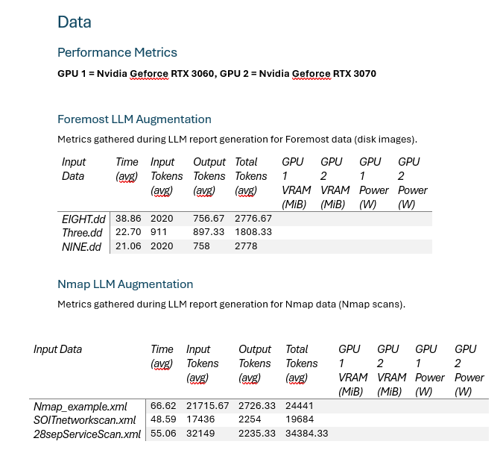
Saturday, October 10
3:00 – 6:15 (3hrs 15)
Working on research report. Comparing the existing human made reports with their LLM-Generated counterparts, writing about performance metrics with graphical representations, running HammerheadV1 to collect screenshots to help illustrate power draw fluctuation during the execution of our solution. Wrote a section on tools/scripts related to the research. Moved raw performance tables to an appendix.

Some of the work I did:
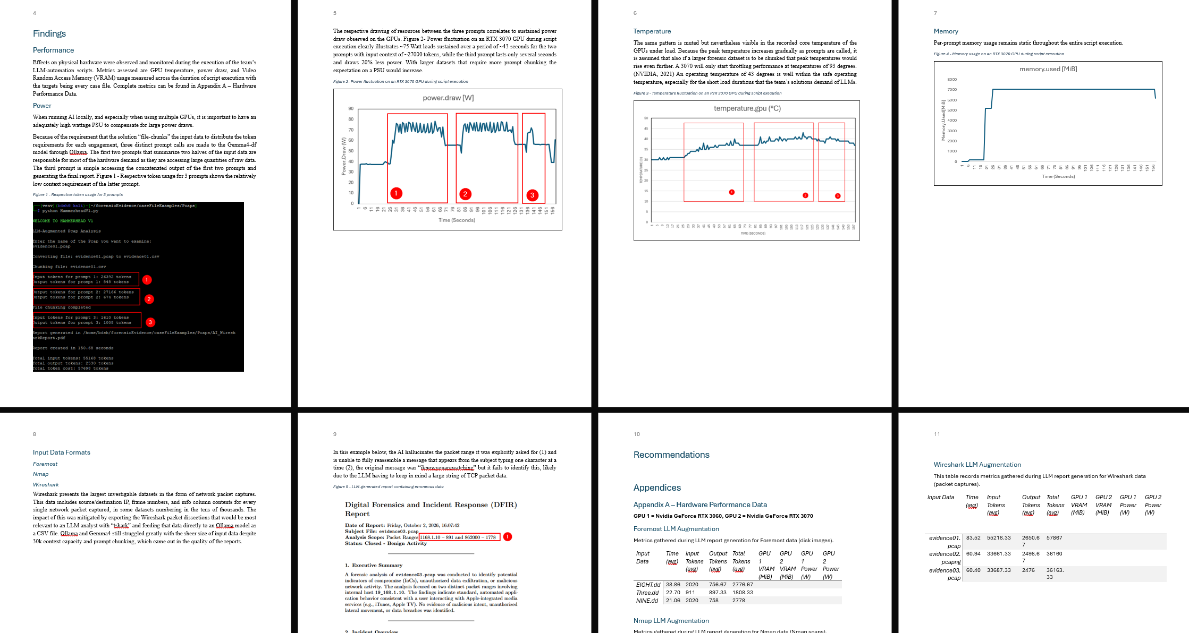
Sunday, October 11
3:15 – 4:30 (1hr 15 mins)
Added the averages from our hardware performance data to the research report as the 27 tests are processed by Sam. Reformatting/resizing tables to they fit when temp column is added. Also, general edits and content added to the research report.
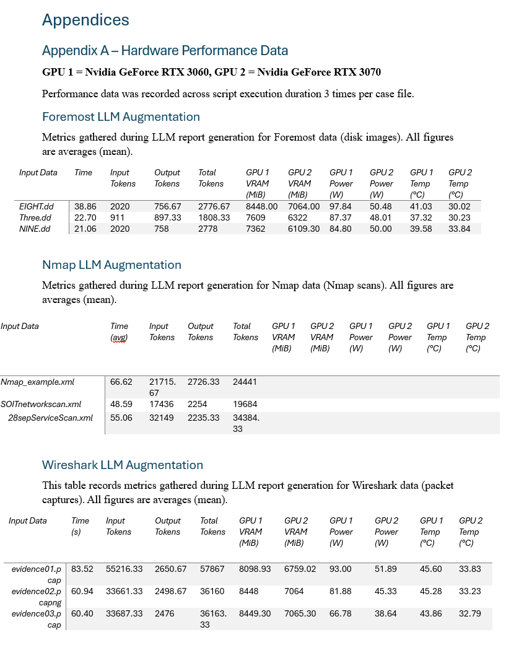
4:30 – 5:45 (1hr 15mins)
Making a preparing content/subjects/ideas for the team’s video.
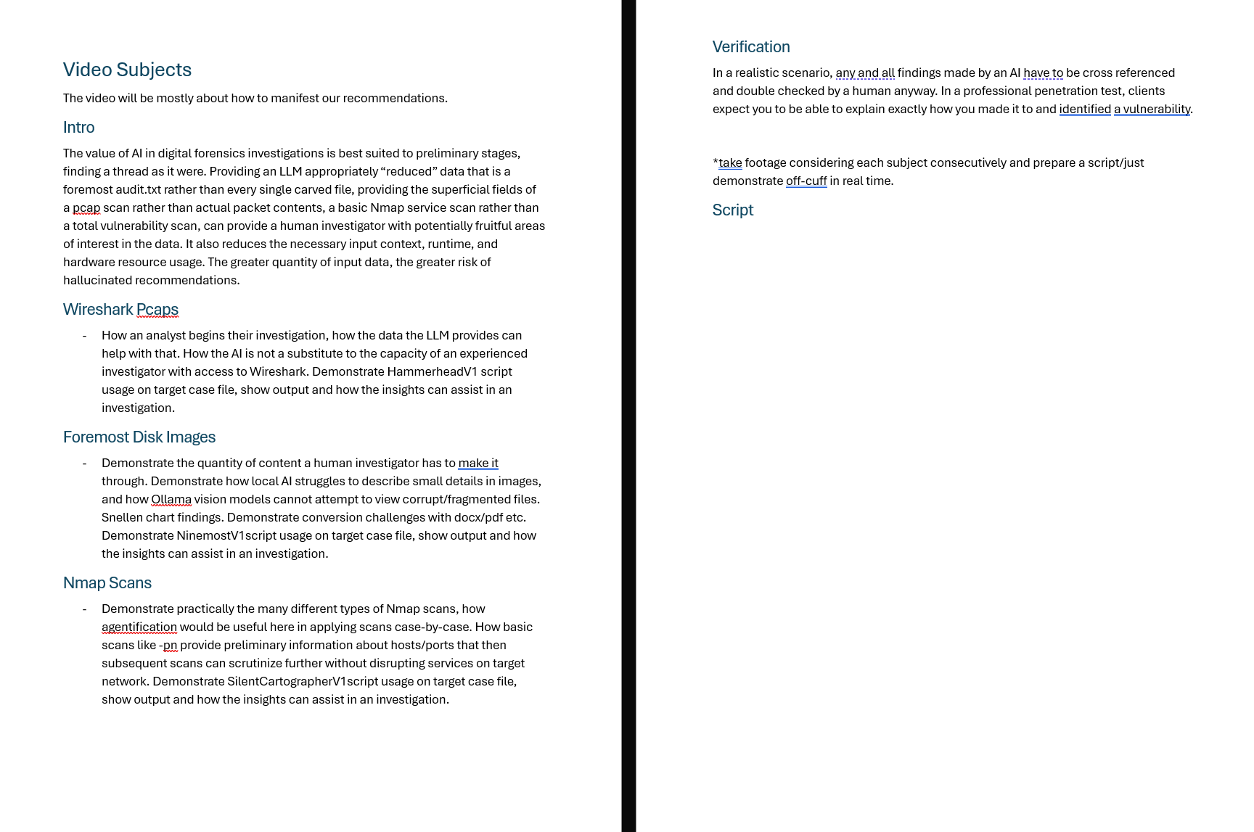
6:45 – 7:00 (15min)
Adding remaining data to research report.
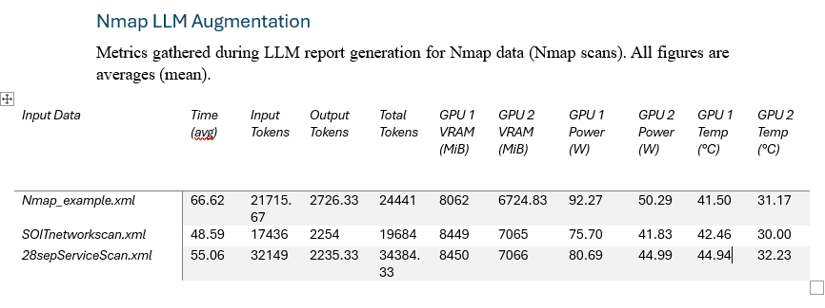

Testing
Wednesday, October 7
6:00 – 7:30 (1hr 30mins)
Testing the new solution and trying to get to the bottom of why packet captures prove to be such a challenge
I test on a packet capture that has 3 times the packets as evidence01.pcap (evidence03.pcap)
I notice that during processing input tokens cap out at 16003
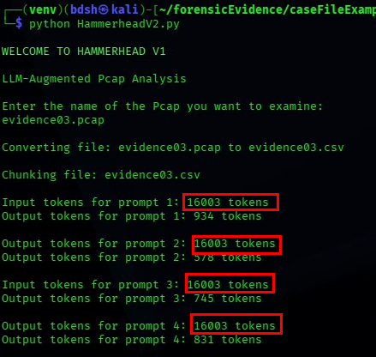
The first chunk that should start at 0 starts at 291 erroneously.
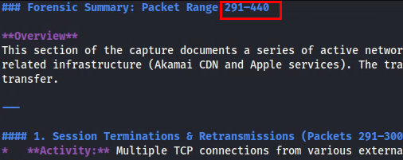

I run a barebones prompt outside of the script on the same data (including with thinking parameter on), asking for just the packet range (1), and it gets it correct(2).
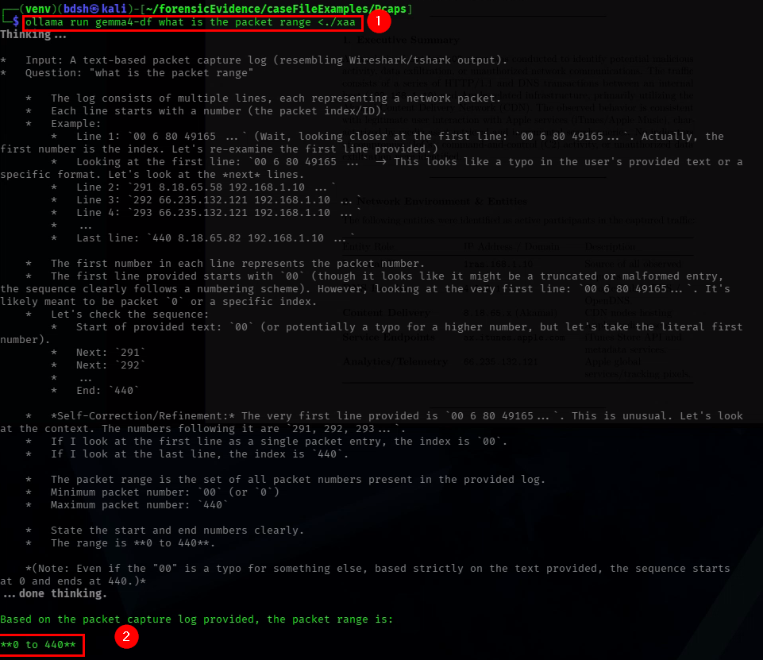
I then use the exact same prompt from the script, and it gets it wrong, in the exact same way
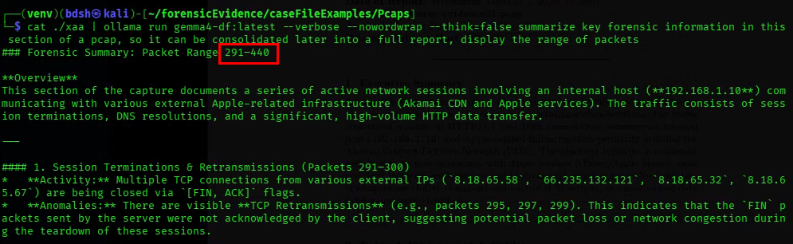

I then test with many different changes to the full command I’m using in the script.
I found the limiting factor to be the actual prompt itself, limiting the prompt to just asking for the packet range gave the most accurate result, but still false in this case.
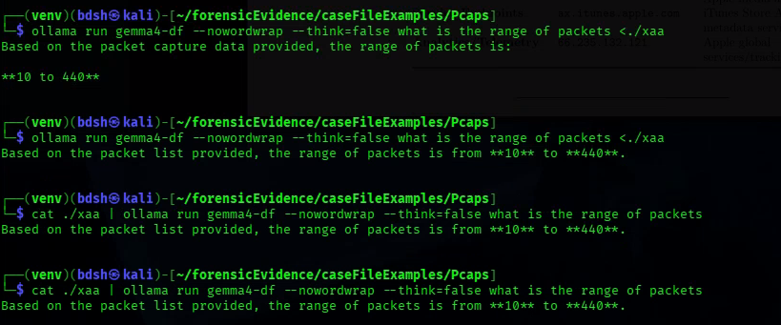
It is possible ollama Is using its memory of previous outcomes to influence the new prompt. As the process is instant if I use the same prompt 2-3 times in a row.
I then try with different models.
Gemma4:latest was able to get the correct range
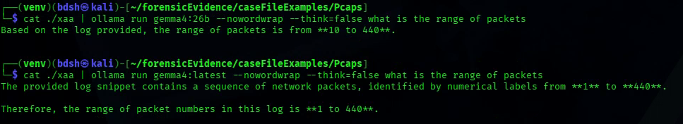
But it struggles with the second chunk’s range (1) despite them being the same size roughly (2)
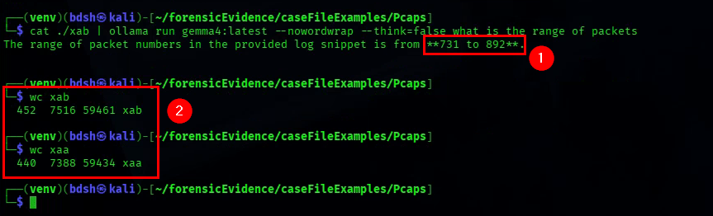
Qwen3.8:27b is the only other model that I tested that could Identify the correct range
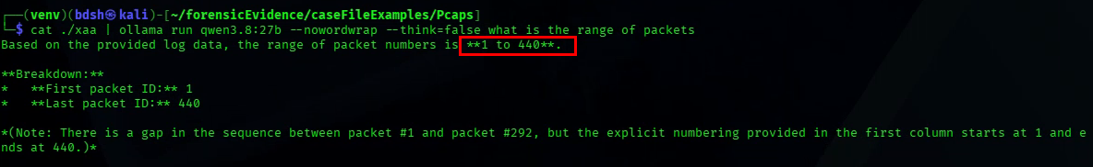
It fails however to identify the packet range for xab.
I also tried converting the data to a token-optimized notation, but it did not reduce its size at all. I will now research PCAP/CSV LLM optimization.

Development
Wednesday, October 7
5:00 – 6:00 (1hr)
Creating a new “HammerheadV2” for Wireshark packet captures. This version is the same as V1 but it attempts to access the full context of the longer PCAP files we have by chunking them into 4 chunks instead of 2.
How the particular problem manifests in the finished reports
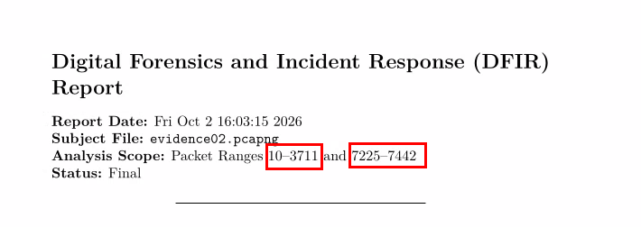
I successfully enable the script to split and prompt 4 chunks, discard the new residuals created, and calculate the token counts with this expanded capacity.

Inspecting the chunks by themselves it seems some of the analysis prompts are reading a limited quantity of the data still, and in fact it seems worse. It is possible there is something happening like Ollama isn’t given enough time to shut down before the next prompt is called.
This chunk summary should start on packet 0, I know at this point that signs of running out of input context are an output that only concerns the lower half of the source data.
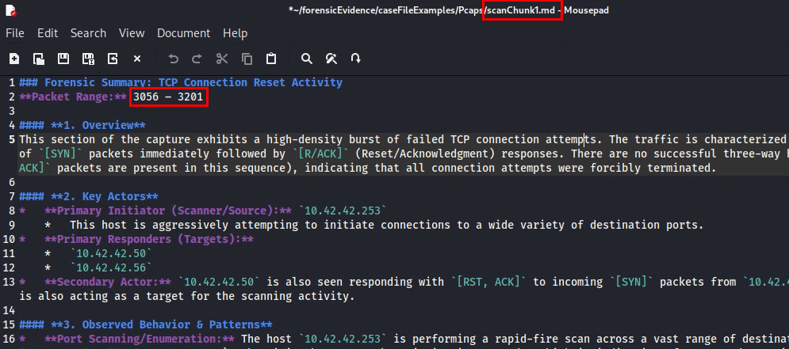
This is the end of the first chunk of the pcap, it ends in 3201, meaning ollama is only accessing about 200 packets worth of data.
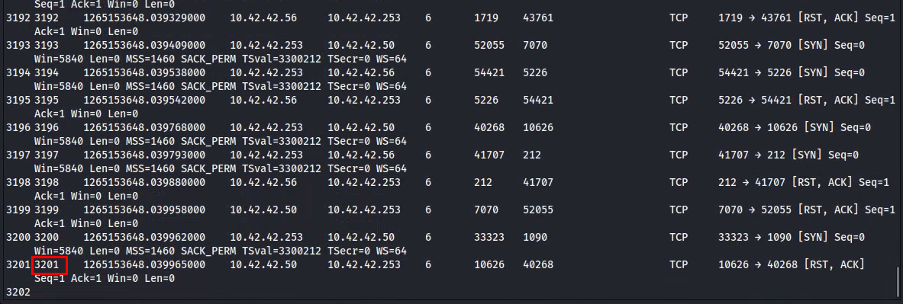
I realise that the frame time is probably using up a lot of context and remove that. I also realise scanchunk1 and 3 are looking at the same packet range and fix that. I forgot to change xaa to xac and xab to xad for the 2 new passes. I am testing on a simple capture of only 572 packets (evidence01)
You can now see that continuity is maintained in the packet chunk summaries.
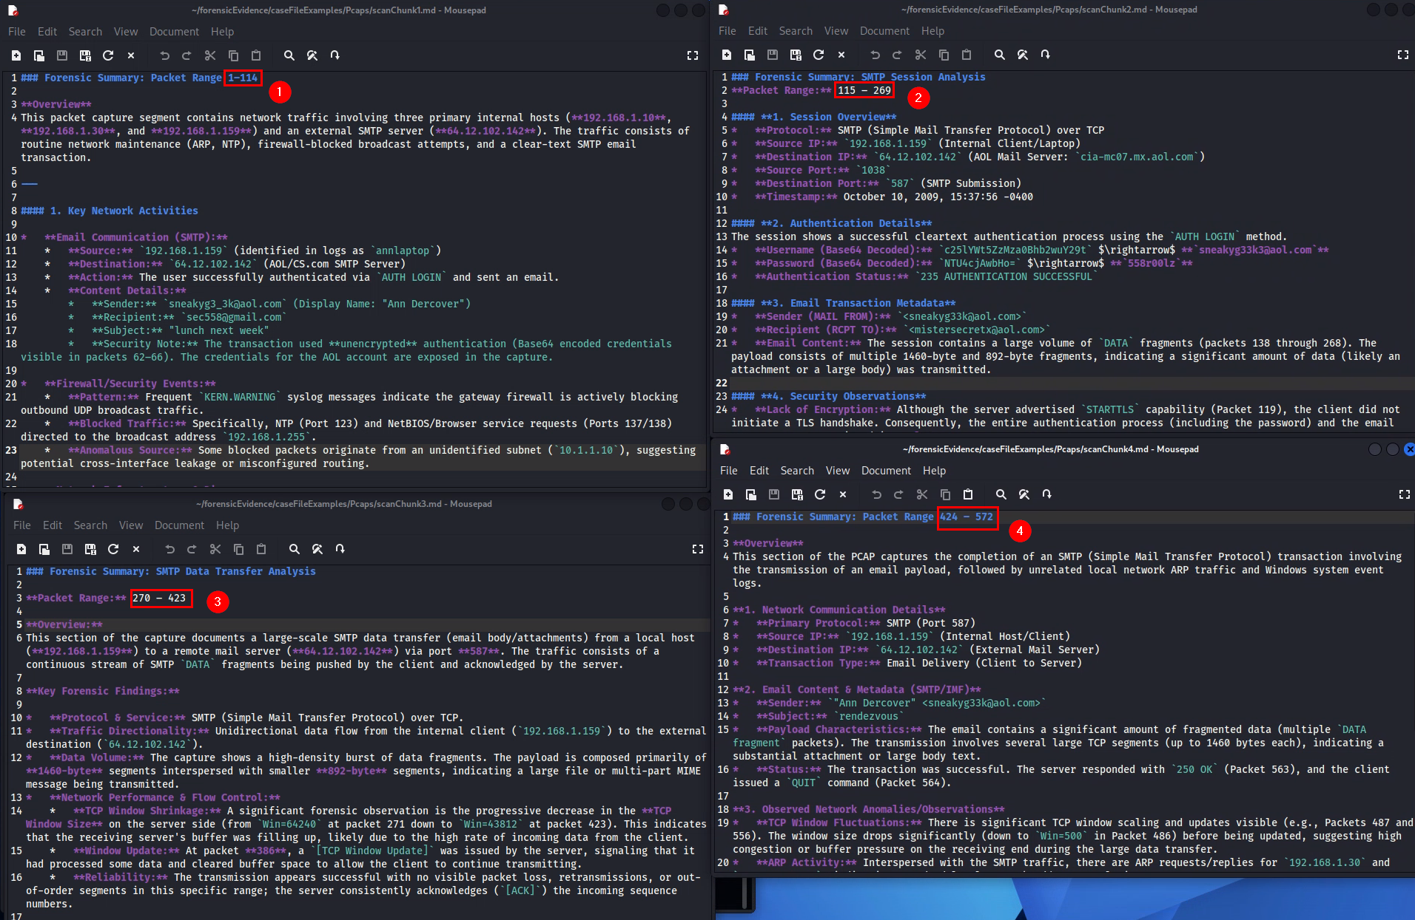

The final report reflects this range too
